University Database – DQL & DML Tasks
DQL
1. Display all student records.
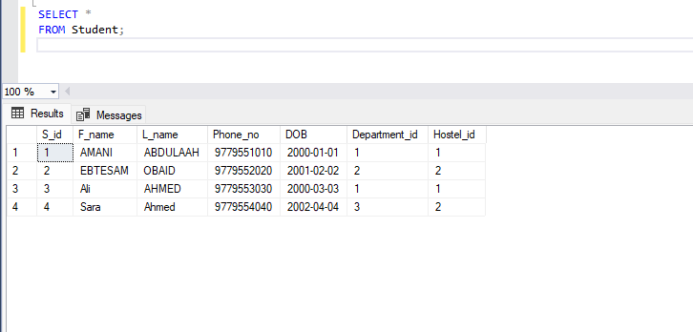
2. Display each student's full name, enrollment date, and current status.
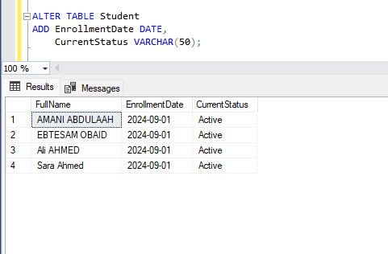
3. Display each course title and credits.
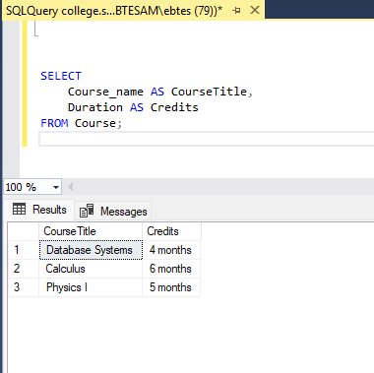
4. Display each student’s full name and GPA as GPA Score.
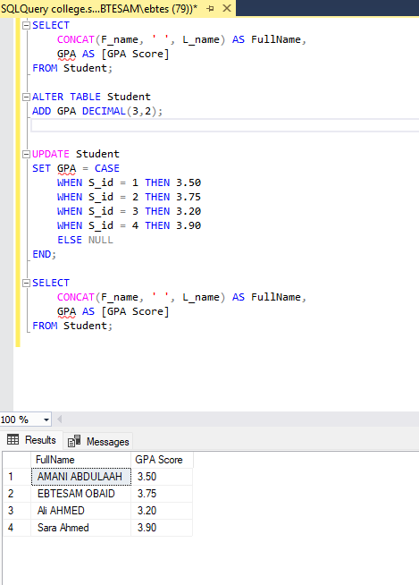
5. List student IDs and names of students with GPA greater than 3.5.
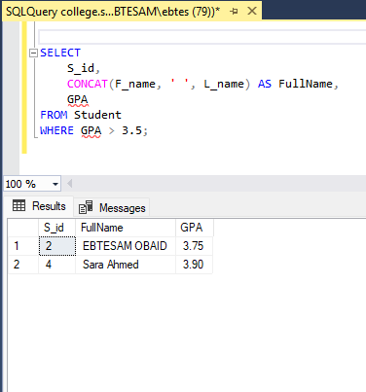
6. List students who enrolled before 2022.
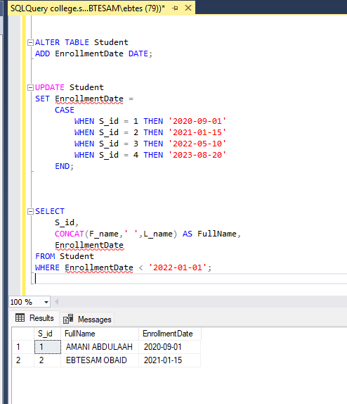

- Display students with GPA between 3.0 and 3.5.
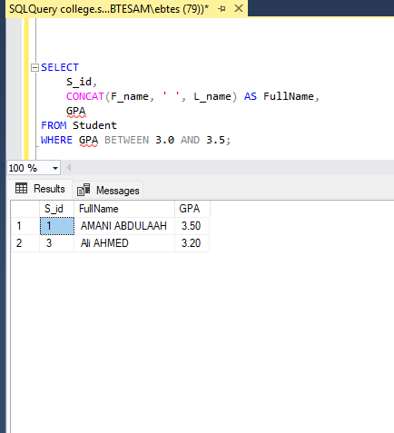
8. Display students ordered by GPA descending.
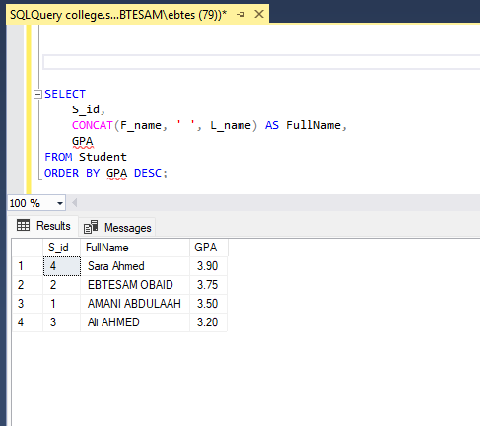
9. Display the maximum, minimum, and average GPA.
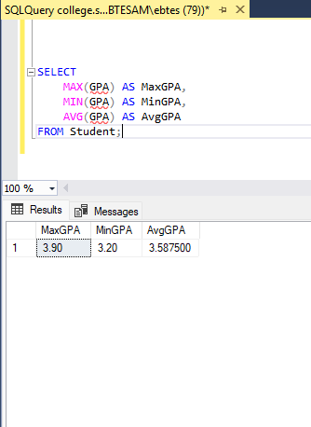

- Display total number of students.
- 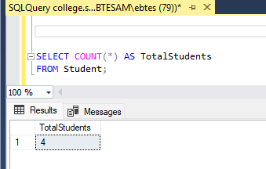
- . Display students whose names end with 'a'.
- 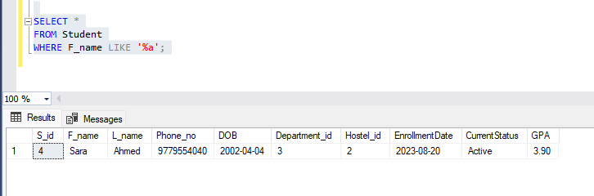
12. Display students with NULL advisor.
- 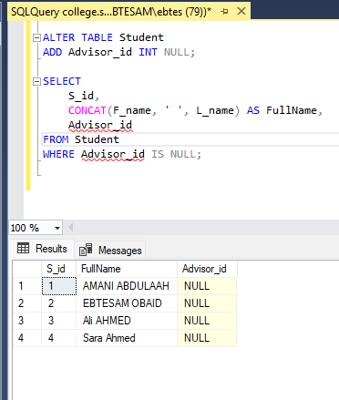

- 13. Display students enrolled in 2021.
DML
14. Insert your data as a new student (Student ID = 300045, Program ID = 2, GPA = 3.6).
15. Insert another student (your friend) with GPA and advisor set to NULL.
16. Increase your GPA by 0.2.
17. Set GPA to 2.0 for students with GPA below 2.0.
18. Increase GPA by 0.1 for students enrolled before 2020.
19. Delete students with status 'Inactive'.

